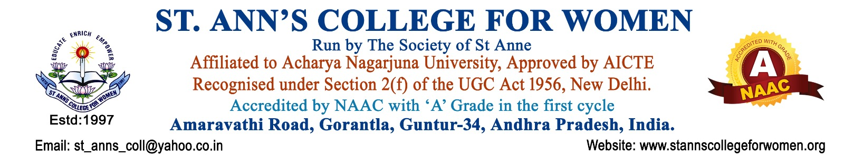

5. COLLABORATION, MoU & CONSULTANCY POLICY
1. Preamble
This policy establishes a structured framework for promoting institutional collaboration, Memoranda of Understanding (MoUs), consultancy activities, and industry engagement to enhance academic quality, research exposure, and skill development.
The policy is aligned with the guidelines of the University Grants Commission and accreditation requirements of the National Assessment and Accreditation Council.
As a private unaided affiliated women’s college, the institution focuses on academic enrichment, experiential learning, skill development, industry exposure, and collaborative academic growth, in accordance with affiliating university regulations.
2. Objectives
The objectives of this policy are to:
- Promote academic, research, and industry collaborations
- Establish structured MoUs with institutions, industries, and organizations
- Enhance student skill development and employability
- Facilitate faculty consultancy and knowledge sharing activities
- Strengthen industry-academia interaction and experiential learning
- Support innovation, research, and extension activities through partnerships
3. Scope
This policy applies to:
- Academic collaborations with universities and colleges
- Industry partnerships and skill-based collaborations
- Consultancy services offered by faculty
- MoUs with organizations, NGOs, and industries
- Student training, internships, and experiential learning activities
4. Types of Collaborations Covered
The institution shall engage in the following types of collaborations:
- Academic Collaboration – Joint seminars, workshops, curriculum enrichment
- Industry Collaboration – Internships, training, placements, and skill development
- Research Collaboration – Joint research projects and publications
- Consultancy Collaboration – Expert advisory services by faculty
- Community/NGO Collaboration – Outreach and social development programmes
5. Memorandum of Understanding (MoU) Framework
5.1 Purpose of MoU
MoUs shall be signed to formalize collaboration for:
- Academic enrichment
- Skill development and training
- Research and innovation
- Internship and placement support
- Faculty and student exchange activities
5.2 MoU Approval Process
- Proposal initiation by concerned department
- Review by IQAC and Principal
- Approval by Governing Body (where required)
- Formal signing and documentation
5.3 MoU Monitoring
- Periodic review of MoU activities
- Submission of activity reports to IQAC
- Documentation for NAAC and audit purposes
6. Consultancy Policy
6.1 Definition
Consultancy refers to expert services provided by faculty members to external organizations in academic, technical, or professional domains.
6.2 Objectives of Consultancy
- Share institutional expertise with external stakeholders
- Enhance faculty professional development
- Generate additional academic and institutional revenue
- Strengthen industry linkages
6.3 Consultancy Guidelines
- Consultancy work shall be approved by the Principal
- It shall not affect regular academic responsibilities
- Proper agreements shall define scope, duration, and remuneration
- Revenue sharing shall follow institutional norms
7. Industry Collaboration Framework
The institution shall promote collaboration with industry for:
- Student internships and industrial training
- Skill development programmes
- Placement support and career guidance
- Guest lectures and expert sessions
- Joint projects and innovation activities
8. Roles and Responsibilities
8.1 Principal
- Overall approval and supervision of collaborations
8.2 IQAC
- Monitoring quality and ensuring NAAC compliance
- Maintaining documentation and evidence
8.3 Departments
- Initiate collaboration proposals
- Implement MoU-based activities
8.4 Faculty Members
- Participate in consultancy and collaborative work
- Guide students in industry exposure activities
9. Financial and Legal Aspects
- All MoUs and consultancy agreements shall be documented in writing
- Revenue sharing, if applicable, shall be transparent and pre-defined
- Activities shall comply with affiliating university and institutional norms
- Legal and ethical standards shall be strictly followed
10. Monitoring and Review
- Annual review of all MoUs and consultancy activities
- Submission of Annual Collaboration Report to IQAC and Governing Body
- Policy review every three years or as per regulatory changes
11. Expected Outcomes
- Stronger industry-academia linkage
- Increased student exposure to real-world environments
- Enhanced employability and skill development
- Improved research and consultancy output
12. Documentation & Evidence
The institution shall maintain:
- Signed MoU copies and renewal records
- Activity reports under each MoU
- Consultancy agreements and reports
- Internship and industry training records
- Workshop and collaborative programme documentation
- IQAC review reports on collaborations

